Be Careful What You Wish For

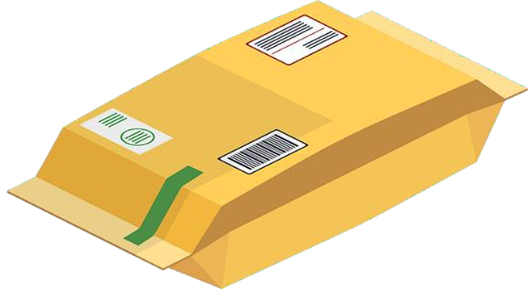“The package is from Uncle Aaron in Scotland,” Rylee told her dad. Her uncle traveled a lot on business, so Rylee rarely got to see him. Her father’s only response was to raise an eyebrow.

Rylee peeled off the wrapping paper and opened the box. She pulled out a large, oval charm suspended on a heavy silver chain. One side of the charm had a symbol of circles and swirls. It looked like writing on the other side, but Rylee did not understand what the words meant.

The box also contained a letter from her uncle. He explained how he had found the necklace at a curious little antique shop. He described how the elderly storekeeper had told him that the charm had special magical powers and warned him to be careful with it.

Her uncle ended the letter with *BE CAREFUL!!!* in big letters and a “laughing” emoji. He did not seem to take the storekeeper’s warnings seriously.

“Let me wear it to school today, Dad,” Rylee pleaded. “Maybe it will bring me luck on my history test.”

“Good grades come from studying, not from luck,” Dad said.

“I did study, but everyone thinks this will be a hard test.” Rylee curled her fingers around the charm she still held, “I wish you’d let me wear it.”

“Yes, you can wear it today.”

That made Rylee stop to wonder, because her dad had never given in that fast before.

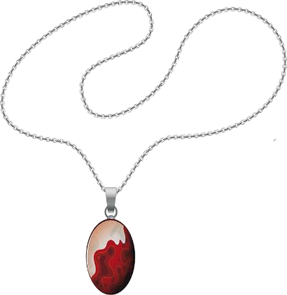At school, Rylee overheard a group of kids talking. Some said her necklace looked ugly, while others thought it silly to believe in good luck charms. Looking down, Rylee rubbed her fingers across the charm. She wished her classmates thought the necklace was as cool as she did.

Without warning, all eyes turned to Rylee and her necklace. Students began to push and shove to get a closer look. Everyone seemed to talk at once, telling her how cool it looked. All Rylee’s friends wanted to borrow her lucky charm.

That made Rylee stop to wonder why everyone changed their minds so fast.

Sitting at her desk, Rylee watched the teacher pass out their tests. She felt like she had frogs jumping around in her stomach. Rubbing her fingers over the charm, Rylee wished that just once she could get the highest mark.

Later in the day, with the tests completed and marked, Rylee’s teacher spoke to the class. “I’m surprised by how poorly many of you did on your test, but one person did very well.” Walking across the room, the teacher handed Rylee her test. “Congratulations Rylee, you earned the highest mark.”

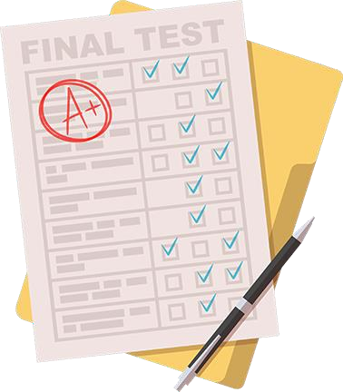Rylee glanced around at the class and, blushing, looked down at her test. Her score was one hundred percent. She had never gotten one hundred percent before.

Belinda, one of Rylee’s closest friends and the hardest working and smartest kid in the class, had only got seventy percent on the test. Belinda gave Rylee a strange look and quietly walked away.

Rylee stared at her test again. Then she looked at Belinda and the other kids, still upset over their poor marks. Rylee was getting a bad feeling about her good luck charm.

On her way home from school, Rylee went to the local museum, found the curator, and showed her the necklace. The lady turned the charm over and back to study it.

“It’s an antique for certain. The knot design engraved on the front does appear to be a symbol of luck. The writing on the back looks like a warning. I f I ’m reading it right, it means ‘*be careful what you wish for.*’” The curator handed the necklace back to Rylee.

Deep in thought, Rylee repeated the words to herself, “Be careful what you wish for.” Was it possible that the necklace could be more than a simple good luck charm? She knew she didn’t want to find out. “Would the museum be interested in it?”

“It’s an interesting piece so I ’m sure we would. Still, if you received it as a gift, I ’m equally sure you’ll want to hang on to it.”

“Actually,” Rylee said, rubbing the charm, “I really wish you’d take it!”